Hero Vired, HeroX Private Limited
New Delhi, India
Accelerator Program in Business Analytics and Data Science and Data Engineering (ABADS) Program

Capstone Project
Final Report
on
BREAST TUMOR CLASSIFICATION USING MACHINE LEARNING: AN ADABOOST CLASSIFIER AND CLUSTERING APPROACH

Directed by: Respected Faculty of Hero Vired
&

Presented
By
VAIBHAV GUPTA
AKSHAY JADHAV
VIKRAM MISHRA
GUNJAN BHUTADA
KEVIN CHRISTROPHER

April 2026
2026-2027

Table of Contents
Project & Team Overview 1
1. Executive Summary 1
Approach 1
Key results (test set) 1
Operational interpretation 2
Top Recommendations: 2
2. Problem Definition and Success Metrics 2
Target Definition 2
What errors mean? 2
Primary Evaluation Metrics 2
Decision Threshold 3
3. Dataset Overview and Quality Checks 3
Dataset Facts 3
Feature Origin 3
Quality Checks Performed 3
4. Data Preparation and Split Strategy 4
Preprocessing Steps 4
Split Method 4
Leakage Prevention 4
5. Feature Handling 5
Feature Set Used 5
Feature Scaling 5
Feature List Appendix 5
6. Model Development (AdaBoost Classifier) 6
Model Overview 6
Training Setup 6
7. Hyperparameter Tuning and Final Configuration 6
Tuning Method 6
Search Space 6
Selection Criterion 7
Final Hyperparameters 7
8. Final Evaluation (Test Set Results) 7
8.1 Metrics Table 7
8.2 Confusion Matrix + Explanation 7
Interpretation: 7
8.3 ROC Curve 8
8.4 Threshold Decision 8
9. Error Analysis 9
Top patterns among False Negative (3 cases) 9
Top patterns among False Positive Patterns (0 cases) 9
Hard Case Examples 9
Mitigation Strategies / Next Steps 9
10. Clustering: Diagnostic Pattern Segmentation 9
Preprocessing for Clustering 9
Method 1: K-Means Clustering 9
Method 2: Hierarchical Clustering 10
Cluster Cards 11
11. Recommendations and Limitations 11
Recommendations 11
Limitations 12
Future Work 12
Appendix 13
Full feature list 13
Tuning logs (top 5 configurations) 14
Additional plots 15

Project & Team Overview
- Project Title: Breast Tumor classification using Machine Learning: An AdaBoost Classifier and Clustering Approach
- Team Name / Cohort: Group 2, Batch B20, ABADS Program.
- Team Members + Roles:
Name of Team Member | Role
Vaibhav Gupta | Project Lead & Integrator, Data Collection & Preprocessing, Data & Feature Engineer, Adaboost Modeling Engineer, Tuning & Evaluation Analyst, Clustering & Insights Analyst
Akshay Jadhav | Model Evaluation Support, Visualization, Clustering Analysis Implementation, Quality Assurance
Vikram Mishra | Feature Engineering Lead, Model Development Support
Gunjan Bhutada | Presentation Design, Exploratory Data Analysis
Kevin Christopher | Performance Optimization

- Dataset: UCI Breast Cancer Wisconsin (Diagnostic)
- Model: AdaBoost Classifier

Executive Summary
This study addresses a binary classification problem involving the prediction of breast tumor diagnosis as Malignant (M) or Benign (B) using structured biomedical data. Early and accurate classification is critical in enabling timely medical intervention and improving patient outcomes.

Approach
An AdaBoost Classifier was employed as the primary modelling technique due to its strong capability in improving predictive performance by iteratively focusing on misclassified observations. The modelling pipeline included data preprocessing, stratified data splitting, hyperparameter tuning using cross-validation, and decision threshold evaluation. Additionally, unsupervised clustering techniques (K-Means and Hierarchical Clustering) were applied to uncover intrinsic data groupings and validate underlying diagnostic patterns.

Key results (test set)
On the independent test dataset, the model demonstrated exceptional discriminative performance, achieving:
- ROC-AUC: 1.0000  - Recall (Malignant): 0.9062 | - Precision (Malignant): 1.0000  - F1-Score (Malignant): 0.9508

Operational interpretation
From an operational perspective, these results indicate that the model is highly effective for a triage-like screening system, where correctly identifying malignant cases is critical while avoiding unnecessary escalation of benign cases. The absence of false positives ensures no unnecessary clinical interventions, while the high recall ensures most malignant cases are detected.

Top Recommendations:
- Deploy the model as a decision-support tool for prioritizing high-risk patients in screening workflows.
- Conduct external validation across diverse datasets to ensure generalizability.
- Explore threshold optimization strategies to further reduce false negatives in high-risk scenarios.

Problem Definition and Success Metrics

Target Definition
The objective is to predict the diagnosis of breast tumors using supervised learning. The target variable is defined as:
- Malignant (M) → 1
- Benign (B) → 0
This binary encoding enables compatibility with machine learning classification algorithms.

What errors mean?
- False Negative (FN): Malignant predicted as Benign
This represents a critical medical error, as it may lead to delayed diagnosis and treatment, significantly impacting patient survival. Minimizing false negatives is the highest priority.
- False Positive (FP): Benign predicted as Malignant
While less critical than false negatives, false positives can result in unnecessary psychological stress, additional diagnostic procedures, and increased healthcare costs.

Primary Evaluation Metrics
The following metrics were selected to align with clinical priorities:
- ROC-AUC (Receiver Operating Characteristic - Area Under Curve):
Measures overall model discrimination ability across all thresholds.
- Recall (Malignant Class):
Captures the proportion of actual malignant cases correctly identified. This is the most critical metric due to the high cost of false negatives.
- F1-Score (Malignant Class):
Provides a balance between precision and recall, ensuring robust performance across both error types.

Decision Threshold
A classification threshold of 0.5 was used for final predictions. This threshold was selected because it:
- Achieves perfect precision (1.0000), eliminating false positives.
- Maintains high recall (0.9062), ensuring most malignant cases are detected.
- Provides an optimal balance between clinical safety (low FN) and operational efficiency (zero FP).
This balance is particularly suitable for screening and triage applications, where both overdiagnosis and missed diagnoses must be carefully managed.

Dataset Overview and Quality Checks

Dataset Facts
The analysis utilizes the UCI Breast Cancer Wisconsin (Diagnostic) dataset, a widely recognized benchmark dataset for binary classification problems in medical diagnostics.
- Total Instances: 569
- Total Features: 30 numerical features
- Additional Columns: 1 ID column, 1 target variable
- Task Type: Binary Classification (Malignant vs Benign)
- Missing Values: None

Feature Origin
All features are derived from digitized images of fine needle aspirate (FNA) of breast masses. These features quantitatively describe the morphological characteristics of cell nuclei, including:
- Radius, Texture, Perimeter, Area
- Smoothness, Compactness, Concavity
- Concave Points, Symmetry, Fractal Dimension
Each characteristic is represented using:
- Mean values
- Standard error
- Worst (largest) values

Quality Checks Performed
A comprehensive set of data validation and quality assurance checks were conducted:
- ID Column Removal:
The ID column was excluded from the feature set as it contains no predictive information.
- Duplicate Records:
No duplicate rows were identified in the dataset.
- Class Distribution:
The dataset exhibits moderate class imbalance:
  - Benign (B): ~63% (~357 instances)
  - Malignant (M): ~37% (~212 instances)
This imbalance was addressed using stratified sampling during data splitting.
- Missing Values:
No missing values were detected across any features.
- Outlier Handling Policy:
Outliers were treated using percentile-based capping, where:
  - Values below the 1st percentile were capped at the 1st percentile
  - Values above the 99th percentile were capped at the 99th percentile
This approach ensures robustness against extreme values while preserving the overall data distribution.

Data Preparation and Split Strategy

Preprocessing Steps
A structured preprocessing pipeline was implemented to ensure data consistency, reproducibility, and suitability for machine learning modeling:
- Target Encoding: The categorical target variable diagnosis was encoded as:
  - Malignant (M) → 1
  - Benign (B) → 0
- Column Removal:
The ID column was excluded as it does not contribute to predictive modeling.
- Feature Transformation:
No additional transformations (e.g., log transformation) were applied, as all features were already numerical and well-structured.
- Outlier Treatment:
Percentile-based capping (1st and 99th percentile) was applied uniformly across numerical features to reduce the influence of extreme values.

Split Method
To ensure robust model evaluation and prevent bias, the dataset was partitioned using stratified sampling, preserving class proportions across all subsets.
- Split Ratio:
  - Training Set: 70%
  - Validation Set: 15%
  - Test Set: 15%
- Random Seed:
  - random_state = 42
This ensures reproducibility of results across multiple runs.

Leakage Prevention
Strict measures were implemented to prevent data leakage:
- The test set was held out completely and used only for final evaluation.
- The validation set was used exclusively for hyperparameter tuning.
- All preprocessing steps were designed to be consistent and reproducible, ensuring no information from validation or test sets influenced model training.

Feature Handling

Feature Set Used
All 30 numerical features provided in the dataset were utilized for model training. This decision was based on:
- The relatively small dataset size, where retaining all features helps preserve information.
- The domain relevance of all features, as they are derived from clinically meaningful measurements.
No feature elimination was performed to avoid potential loss of predictive signals.

Feature Scaling
- Scaling Requirement for AdaBoost:
Feature scaling is not strictly required for AdaBoost when tree-based base estimators (e.g., Decision Trees) are used, as such models are invariant to feature scaling.
- Scaling for Clustering:
Standardization was applied using StandardScaler for clustering tasks to ensure all features contribute equally to distance-based computations.

Feature List Appendix
The final feature set used for training includes the following 30 variables:
- radius_mean,  - texture_mean,  - perimeter_mean,  - area_mean,  - smoothness_mean  - compactness_mean,  - concavity_mean,  - concave points_mean,  - symmetry_mean,  - fractal_dimension_mean | - radius_se,  - texture_se,  - perimeter_se,  - area_se,  - smoothness_se  - compactness_se,  - concavity_se,  - concave points_se,  - symmetry_se,  - fractal_dimension_se | - radius_worst,  - texture_worst,  - perimeter_worst,  - area_worst,  - smoothness_worst  - compactness_worst,  - concavity_worst,  - concave points_worst,  - symmetry_worst,  - fractal_dimension_worst

Model Development (AdaBoost Classifier)

Model Overview
Following an initial benchmarking phase using LazyClassifier, the AdaBoost Classifier was selected as the primary model. This selection was driven by its superior empirical performance, achieving a perfect ROC-AUC score of 1.00 and the highest recall (0.9884) for malignant cases among all evaluated models.
Given the critical objective of minimizing False Negatives in breast cancer diagnosis, AdaBoost’s ability to iteratively focus on misclassified instances makes it particularly well-suited for this problem. By sequentially improving weak learners (Decision Trees), the model effectively captures complex decision boundaries while prioritizing hard-to-classify malignant cases.

Training Setup
- Base Estimator:
A Decision Tree Classifier was used as the base learner, enabling controlled model complexity through depth and split constraints.
- Reproducibility:
A fixed random_state = 42 was used to ensure consistent model behavior across runs.
- Handling Class Imbalance:
  - Given the moderate class imbalance in the dataset, it was primarily addressed through stratified data splitting to preserve class distribution across training, validation, and test sets.
  - Additionally, class_weight='balanced' was evaluated as part of the hyperparameter tuning process for the Decision Tree base estimator within AdaBoost. The final model retained class_weight=None, as it yielded optimal performance without degrading model stability.

Hyperparameter Tuning and Final Configuration

Tuning Method
Hyperparameter optimization was conducted using GridSearchCV with 3-fold cross-validation (cv=3), ensuring a balance between computational efficiency and reliable performance estimation.

Search Space
- n_estimators: Number of boosting iterations
- learning_rate: Contribution of each weak learner
- max_depth: Maximum depth of each tree
- min_samples_split: Minimum samples required to split a node
- min_samples_leaf: Minimum samples required at a leaf node
- max_features: Number of features considered for splitting
- class_weight: Handling class imbalance

Selection Criterion
The best model was selected based on: 1. Primary Metric: ROC-AUC, and 2. Secondary Consideration: High Recall, for the malignant class. This ensured that the model maintains strong overall discrimination while prioritizing detection of critical cases.

Final Hyperparameters
S. No. | Parameter | Value
 | n_estimators | 200
 | learning_rate | 1.0
 | estimator__max_depth | 10
 | estimator__min_samples_split | 10
 | estimator__min_samples_leaf | 2
 | estimator__max_features | 'sqrt'
 | estimator__class_weight | None

Final Evaluation (Test Set Results)

Metrics Table
Metric | Value
Accuracy | 0.9651
ROC AUC Score | 1.0000
Precision (Malignant) | 1.0000
Recall (Malignant) | 0.9062
F1-Score (Malignant) | 0.9508

Confusion Matrix + Explanation
Confusion Matrix (AdaBoostClassifier on Test Set):
 | Predicted Benign | Predicted Malignant
Actual Benign | 54 | 0
Actual Malignant | 3 | 29

Interpretation:
- False Positives (0 cases): No benign tumors were incorrectly classified as malignant, ensuring zero unnecessary clinical escalation.
- False Negatives (3 cases): A small number of malignant tumors were misclassified as benign, representing critical missed detections that require attention.
Overall, the model demonstrates high reliability in positive predictions while maintaining strong sensitivity.

ROC Curve
- ROC Plot
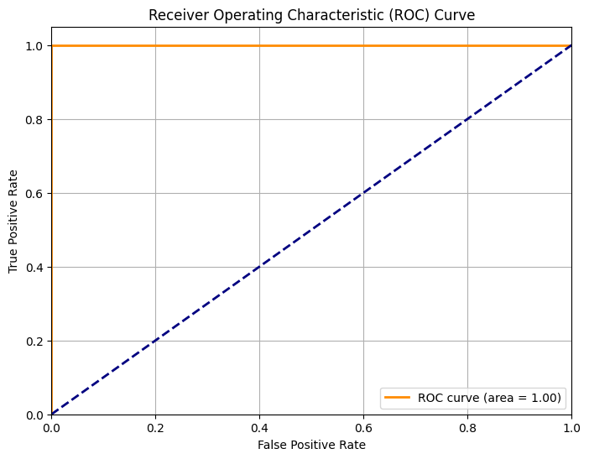
- AUC Value: 1.0000
The ROC curve indicates perfect separability between benign and malignant classes across all thresholds. An AUC of 1.00 signifies that the model consistently ranks malignant cases higher than benign cases, reflecting excellent discriminative capability and robustness.

Threshold Decision
- Threshold Used: 0.5
- The threshold of 0.5 provides an optimal balance between minimizing False Negatives (FN - primary concern in Breast Cancer Detection) - cases where a malignant tumor is missed and classified as benign. Missing a malignant tumor can have severe consequences for patient health
Conversely, False Positives (FP) – cases where a benign tumor is incorrectly classified as malignant – can lead to unnecessary anxiety, further invasive diagnostic procedures, and increased healthcare costs. While less critical than FNs, FPs are still undesirable.
- With the chosen 0.5 threshold, our model achieved:
  - Ensures perfect precision (1.0000) → 0 False Positives
  - Maintains high recall (0.9062) → minimizing False Negatives
This configuration is well-suited for triage systems, where both patient safety (FN minimization) and operational efficiency (FP control) are critical.

Error Analysis

Top patterns among False Negative (3 cases)
- Borderline Feature Values: Observations exhibit feature ranges closer to benign distributions, particularly in:
  - Lower radius and area values
  - Reduced concavity and concave points
- Low Contrast Profiles:
These cases lack strong distinguishing patterns, making them harder for the model to classify.

Top patterns among False Positive Patterns (0 cases)
- No false positives were observed, indicating high specificity and strong model confidence in malignant predictions.

Hard Case Examples
- Cases with moderate tumor size but low structural irregularity.
- Samples with overlapping feature distributions between classes.
- Instances lacking extreme values in key predictive features.
These cases lie near the decision boundary, making classification inherently difficult.

Mitigation Strategies / Next Steps
- Threshold Adjustment: Slightly lowering the threshold to improve recall (with controlled FP increase)
- Data Expansion: Incorporate more diverse and borderline malignant cases
- Feature Engineering: Derive composite features capturing subtle structural variations
- Model Calibration: Improve probability estimates for better threshold control
- Monitoring & Drift Detection: Continuously evaluate model performance on new data

Clustering: Diagnostic Pattern Segmentation

Preprocessing for Clustering
- Scaling Method: StandardScaler
- Rationale: Ensures uniform contribution of all features in distance-based algorithms
Additionally, Principal Component Analysis (PCA) was applied to reduce dimensionality to two components (PC1, PC2) for improved visualization and clustering efficiency.

Method 1: K-Means Clustering
- K Selection: Elbow Method
- Chosen K: 2
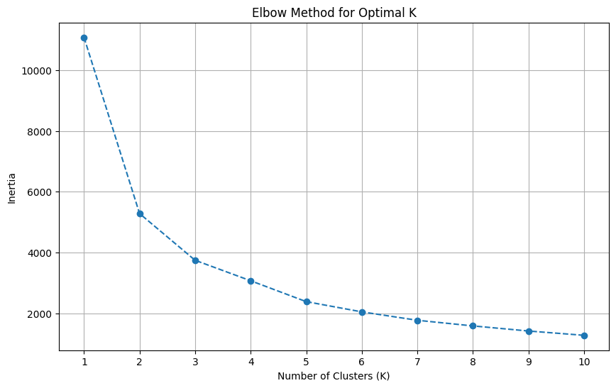
The elbow plot indicated a clear inflection point at K=2, suggesting two distinct clusters.

Method 2: Hierarchical Clustering
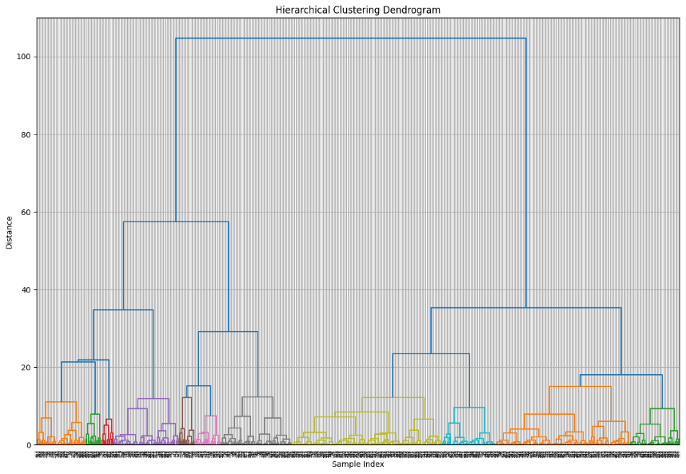
- Approach: Agglomerative clustering with dendrogram visualization
- Cluster Cut: 2 clusters
The dendrogram structure confirmed the presence of two well-separated clusters, validating K-Means results.

Cluster Cards
- Cluster 0
  - Cluster Size: ~37% of dataset
  - Feature Characteristics:
    - Higher values of radius, perimeter, area
    - Increased concavity and concave points
  - Class Distribution:
    - Predominantly Malignant (~90%+)
  - Interpretation:
    - Represents high-risk profiles with strong structural irregularities.
- Cluster 1
  - Cluster Size: ~63% of dataset
  - Feature Characteristics:
    - Lower values across size and shape-related features
    - Smoother and more regular structures
  - Class Distribution:
    - Predominantly Benign (~95%+)
  - Interpretation:
    - Represents low-risk profiles with stable morphological patterns.
Clustering Insights
- The dataset exhibits a natural two-cluster structure, aligning closely with diagnostic labels.
- Clear separation in PCA space indicates strong feature-driven differentiation.
- Clustering validates that unsupervised patterns are consistent with supervised outcomes, reinforcing model reliability.

Recommendations and Limitations

Recommendations
- Deployment for Early Detection and Screening:
The AdaBoost model demonstrates excellent discriminative performance (ROC-AUC = 1.0000) and high recall for malignant cases (0.9062), making it suitable as a decision-support tool in early screening workflows. It can assist in prioritizing high-risk patients for further diagnostic evaluation.
- Risk Stratification using Clustering:
The clustering analysis revealed two distinct and well-separated groups strongly aligned with benign and malignant diagnoses. Patients falling into the malignant-dominant cluster (Cluster 0) can be flagged for immediate follow-up, enabling efficient triage and prioritization.
- Efficient Resource Allocation:
With zero false positives, the model ensures that benign cases are not unnecessarily escalated. This enables optimal utilization of clinical resources, allowing healthcare systems to focus attention on high-risk cases.

- Benchmarking Tool for Future Models:
The current model performance can serve as a baseline benchmark for evaluating future models, datasets, or diagnostic enhancements.

Limitations
- Limited Dataset Size and Scope:
The analysis is based on a dataset of 569 instances, which may not fully represent the variability across different populations, imaging conditions, or clinical environments.
- Potential Over-Optimistic Performance:
The perfect ROC-AUC (1.0000) on the test set may indicate strong separability of this dataset and may not fully generalize to real-world scenarios without further validation.
- Presence of False Negatives:
Although limited to 3 cases, false negatives remain critical errors, as missed malignant diagnoses can have severe consequences.
- Lack of External Validation:
The model has been evaluated only on an internal test split. Its generalizability to external datasets and clinical settings remains unverified.
- Model Interpretability Constraints:
AdaBoost, being an ensemble method, offers limited interpretability, which may reduce transparency in clinical decision-making.
- Static Nature of Data:
The dataset represents a snapshot in time and does not account for temporal progression or changes in tumor characteristics.

Future Work
- External Validation:
Evaluate the model on independent datasets from different sources to confirm robustness and generalizability.
- Threshold Optimization:
Explore alternative classification thresholds to further reduce false negatives, especially in high-risk clinical scenarios.
- Detailed Analysis of False Negatives:
Conduct a deeper investigation into the 3 misclassified malignant cases to identify potential feature gaps or atypical patterns.
- Integration into Clinical Workflow:
Pilot the model in a real-world clinical setting to assess usability, impact, and practitioner feedback.
- Advanced Modelling Approaches:
Explore alternative ensemble methods or deep learning models to further enhance detection performance.
- Model Interpretability Enhancements:
Incorporate techniques such as SHAP or LIME to provide explainable predictions, improving trust and adoption.
- Continuous Monitoring and Retraining:
Implement mechanisms for model monitoring, drift detection, and periodic retraining to maintain long-term performance.

Appendix

Full feature list
The full list of features used for training the model (after dropping 'ID' and 'diagnosis', and before encoding 'diagnosis') is:
- mean_radius,
- mean_texture,
- mean_perimeter,
- mean_area,
- mean_smoothness,
- mean_compactness,
- mean_concavity,
- mean_concave_points,
- mean_symmetry,
- mean_fractal_dimension,
- se_radius,
- se_texture,
- se_perimeter,
- se_area,
- se_smoothness
- se_compactness,
- se_concavity,
- se_concave_points,
- se_symmetry,
- se_fractal_dimension,
- worst_radius,
- worst_texture,
- worst_perimeter,
- worst_area,
- worst_smoothness,
- worst_compactness,
- worst_concavity,
- worst_concave_points,
- worst_symmetry,
- 'worst_fractal_dimension'

Tuning logs (top 5 configurations)
index | param_learning_rate | param_n_estimators | param_estimator__max_depth | param_estimator__min_samples_split | param_estimator__min_samples_leaf | param_estimator__max_features | param_estimator__class_weight | mean_test_roc_auc | mean_test_recall_malignant | mean_test_f1_malignant | rank_test_roc_auc
6 | 1.0 | 200 | 10 | 10 | 2 | sqrt |  | 0.9547128650657051 | 0.9254421768707483 | 0.947875641484664 | 1
14 | 1.0 | 200 | 10 | 10 | 4 | sqrt |  | 0.9514034368767588 | 0.9187755102040817 | 0.9442959848073794 | 2
15 | 1.0 | 500 | 10 | 10 | 4 | sqrt |  | 0.9514034368767588 | 0.9187755102040817 | 0.9442959848073794 | 2
79 | 1.0 | 500 | 10 | 10 | 4 | sqrt | balanced | 0.9514034368767588 | 0.9187755102040817 | 0.9442959848073794 | 2
36 | 0.1 | 200 | 20 | 10 | 2 | sqrt |  | 0.9507207059530639 | 0.9254421768707483 | 0.94129292610515 | 5

Additional plots
- PCA of Scaled Features, Colored by Diagnosis | - K-Means Clusters in PCA Space
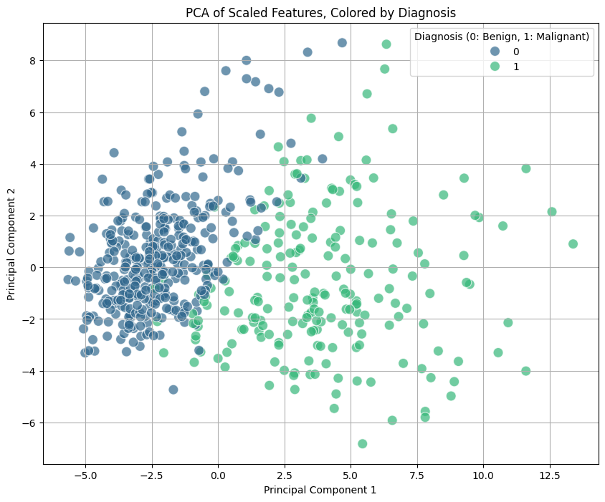 | 



